**Apache Tomcat**

**Apache Tomcat** is an open-source web server and servlet container developed by the **Apache** **Software Foundation** (ASF). Tomcat implements several Java EE specifications including Java Servlet, Java Server Pages (JSP), Java EL, and WebSocket, and provides a "pure Java" HTTP web server environment for Java code to run in.

**Pre-requisites for installing Apache Tomcat :**

The packages needed for Apache Tomcat to function are :

* Java SE Runtime Environment (JRE)
* Java Development Kit (JDK)

**Installation of Apache Tomcat in Windows:**

In this documentation we will be installing Apache Tomcat version 9.0 on Windows 10.

1. To install Apache Tomcat, go to, <http://tomcat.apache.org/download-90.cgi>, then from Binary Distribution/core/ download the “.zip” package.
2. Unzip the file and paste the extracted file in any directory.
3. **Set the environment variables.**
   1. To do this, right click on This PC, go to Properties

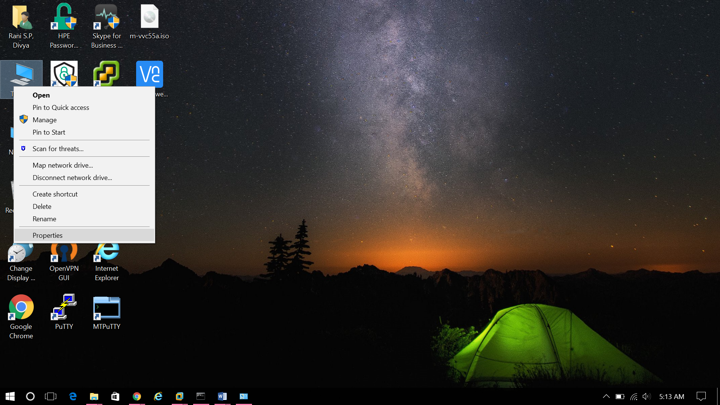

* 1. Select Advanced system settings

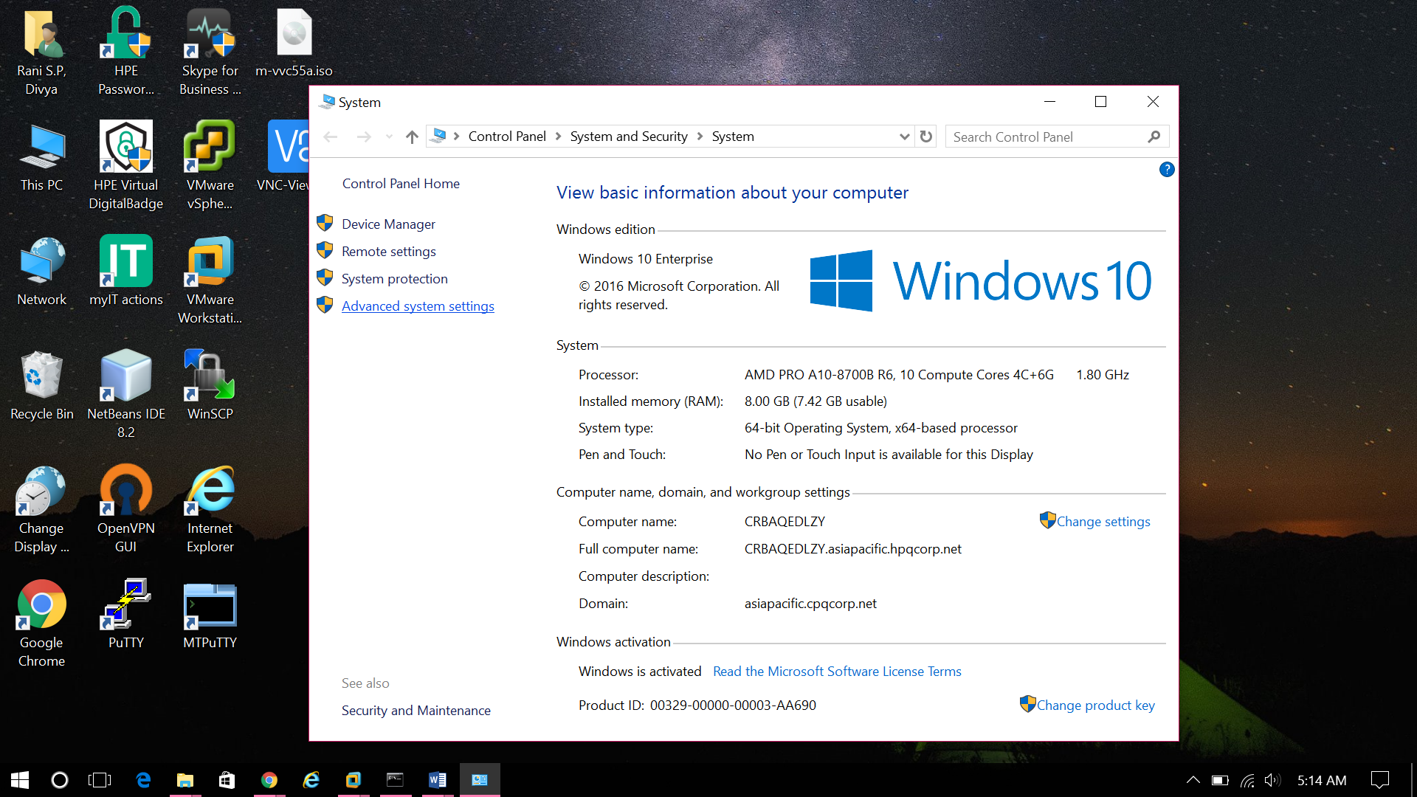

* 1. Select the Environment Variables option

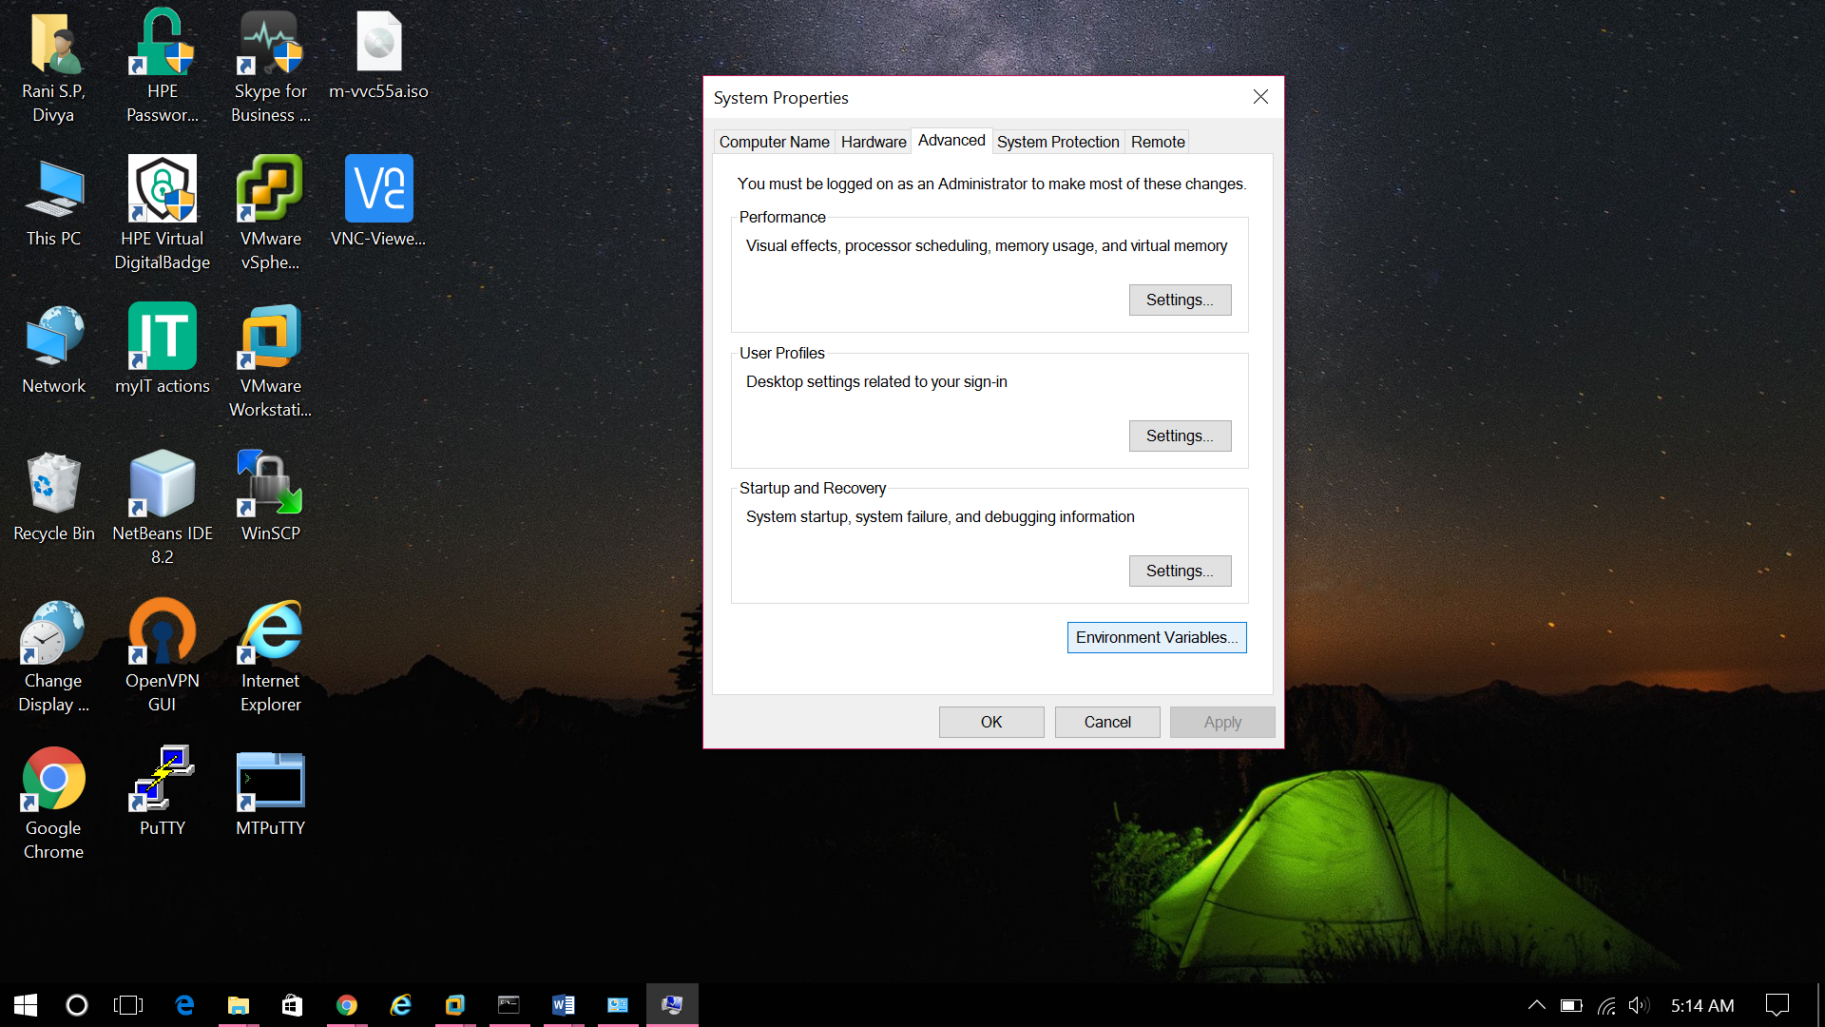

* 1. Set the CLASSPATH variable as,

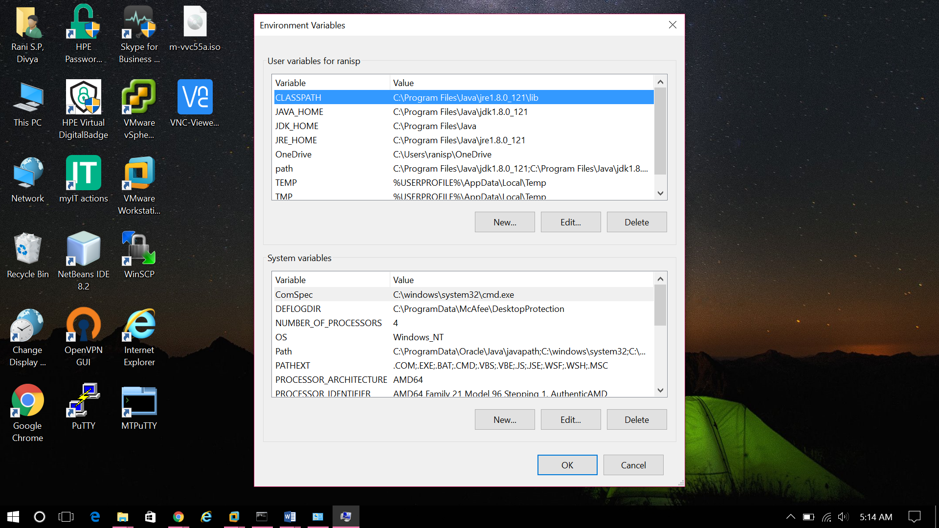

* 1. Set the JAVA_HOME variable as,

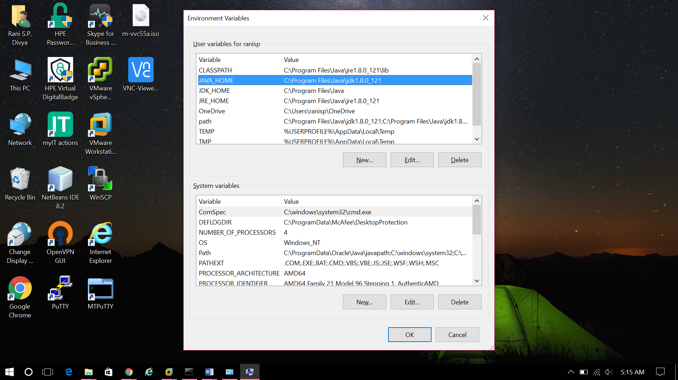

* 1. Set the JDK_HOME variable as,

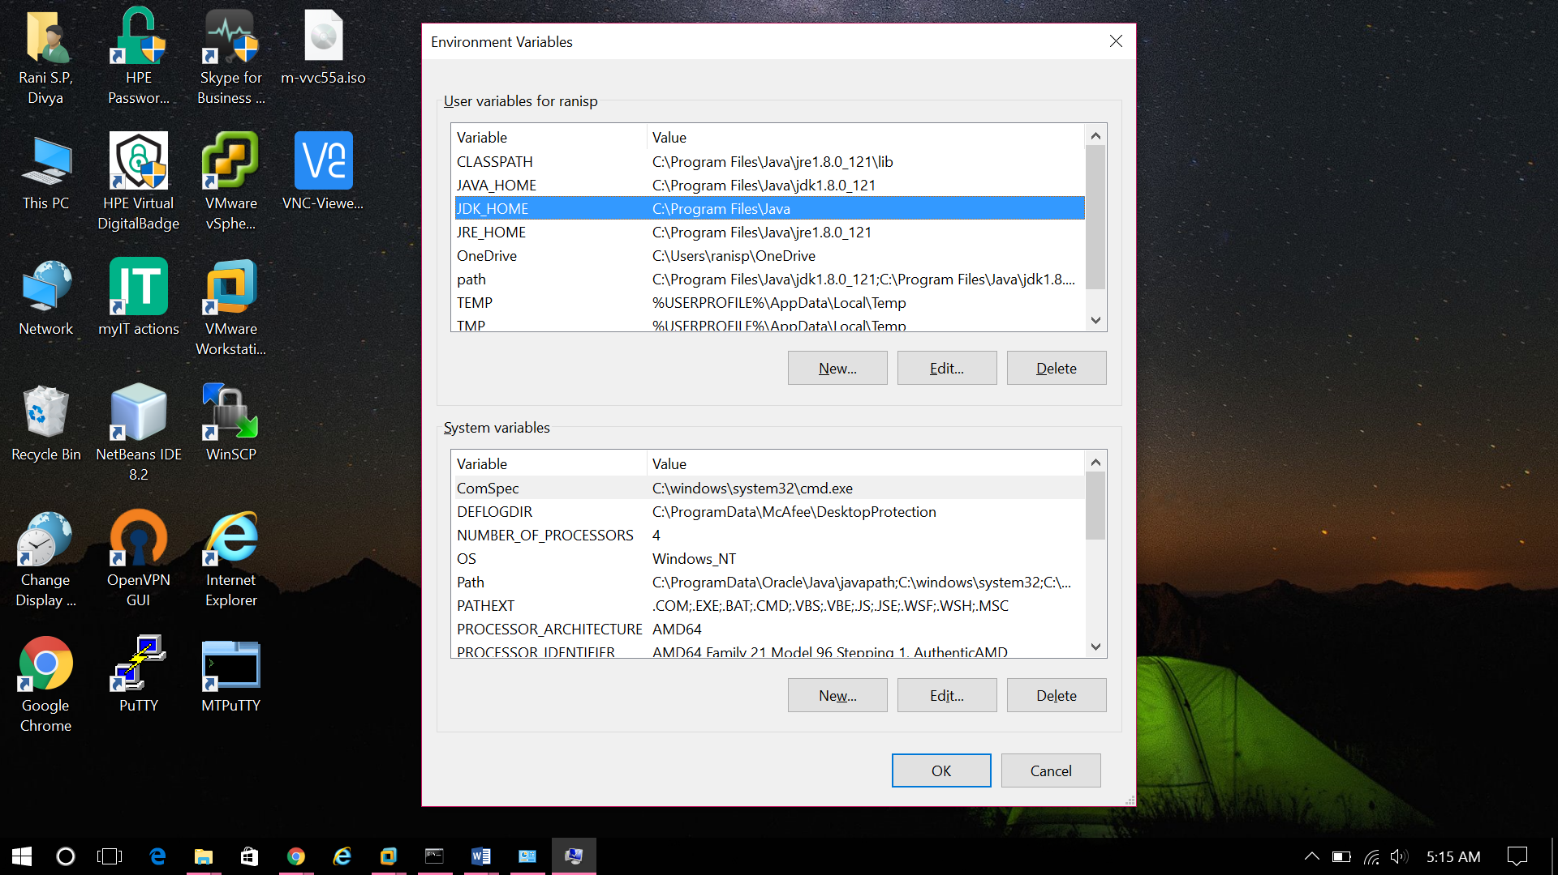

* 1. Set the JRE_HOME variable as,

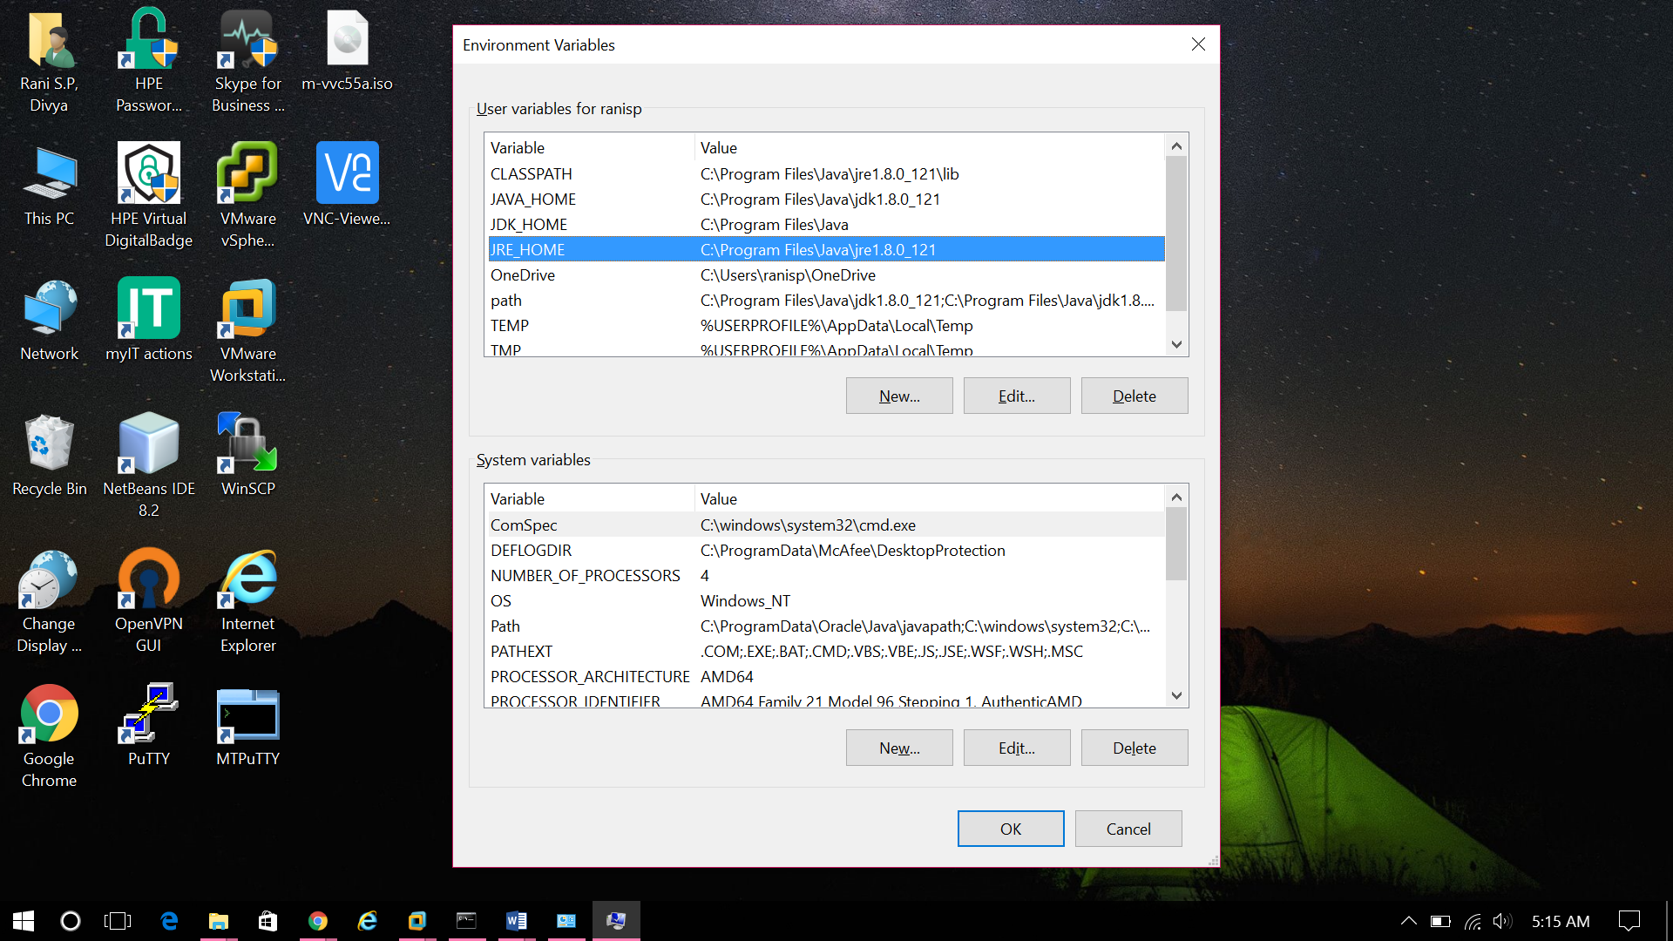

1. **Configuring Apache Tomcat Server**

The configuration files of the Apache Tomcat Server are located in the "conf" sub-directory of our Tomcat installed directory (C:\Program Files (x86)\apache-tomcat-9.0.0.M18\conf).

Here there are 4 configuration XML files,

1. context.xml file
2. tomcat-users.xml file
3. server.xml file
4. web.xml file

The connector port number can be changed in the server.xml file.

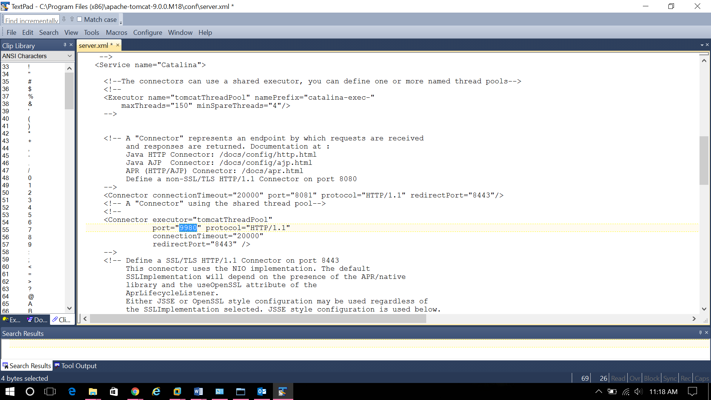

1. **Start tomcat server**
   1. To start the tomcat server, go to apache-tomcat-9.0.0.M18\bin, run the startup.bat file.
   2. Next, to access the server, open the browser give the URL as <http://localhost:80>90. Here 8090 is the default port number.

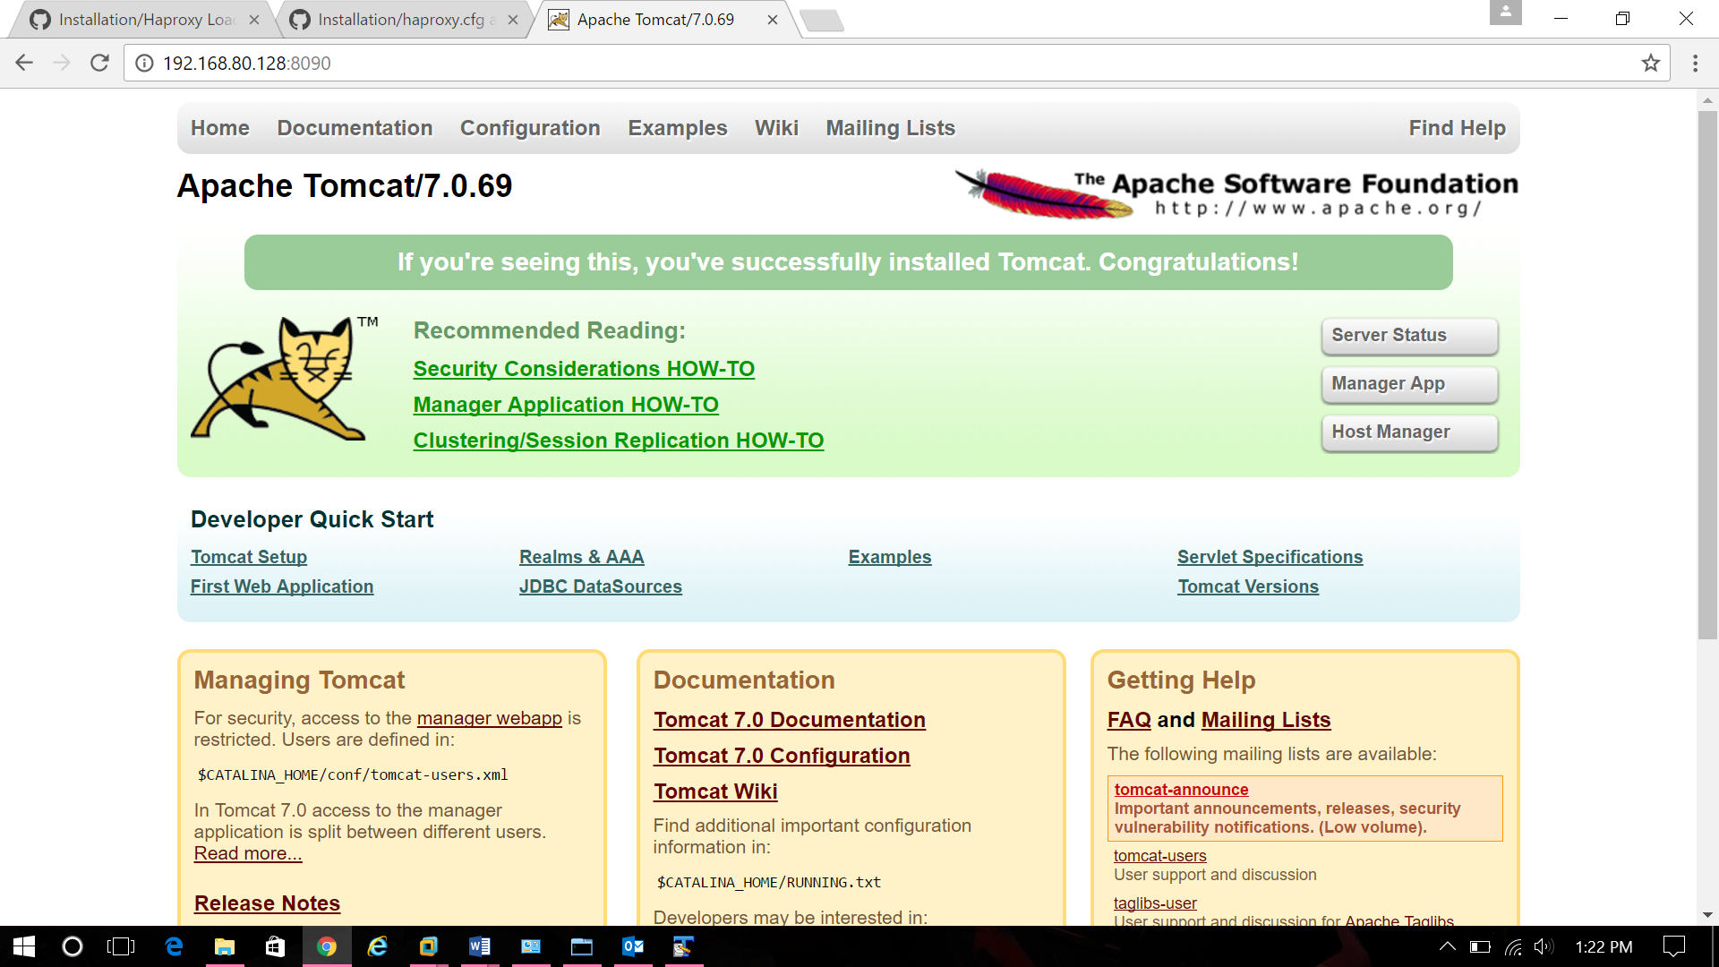

**Integrating Apache Tomcat server to Eclipse (IDE)**

1. Open Eclipse, go to Windows -> Preferences

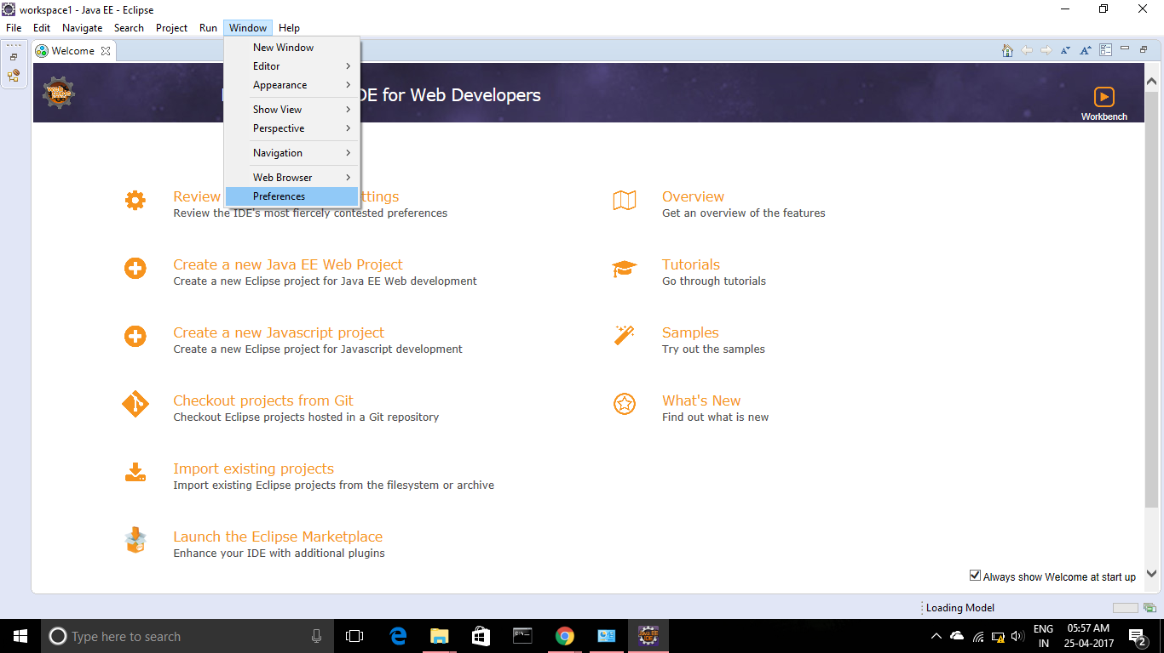

1. Go to Server-> Runtime Environment and select the add option.

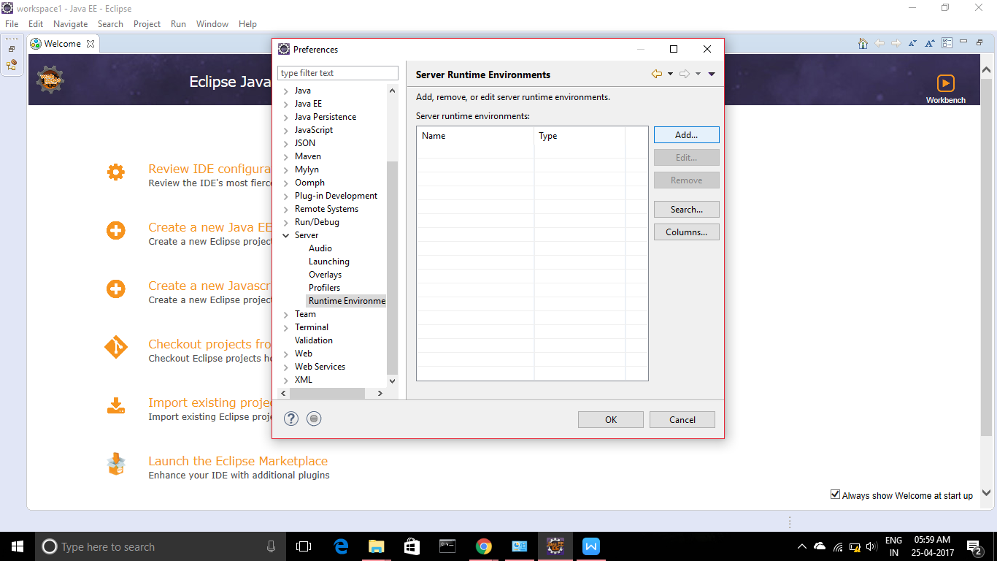

1. Select the required tomcat version

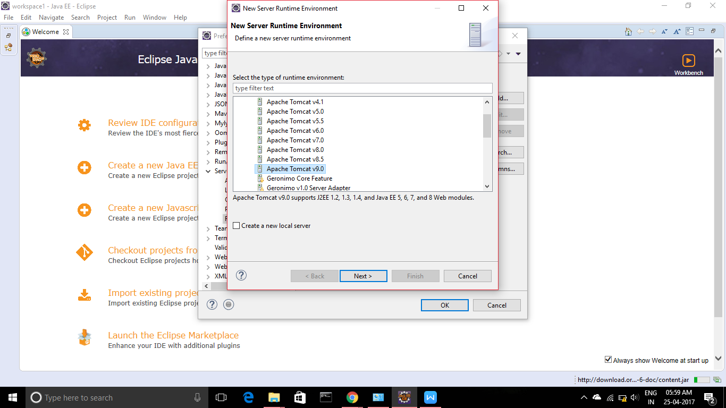

1. Give the path where tomcat is located

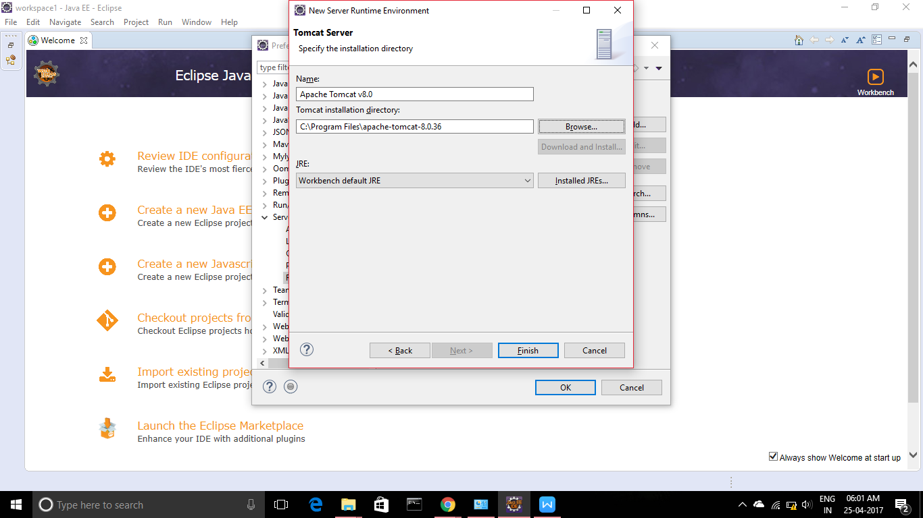

1. Select the required Java Runtime Environment (JRE).

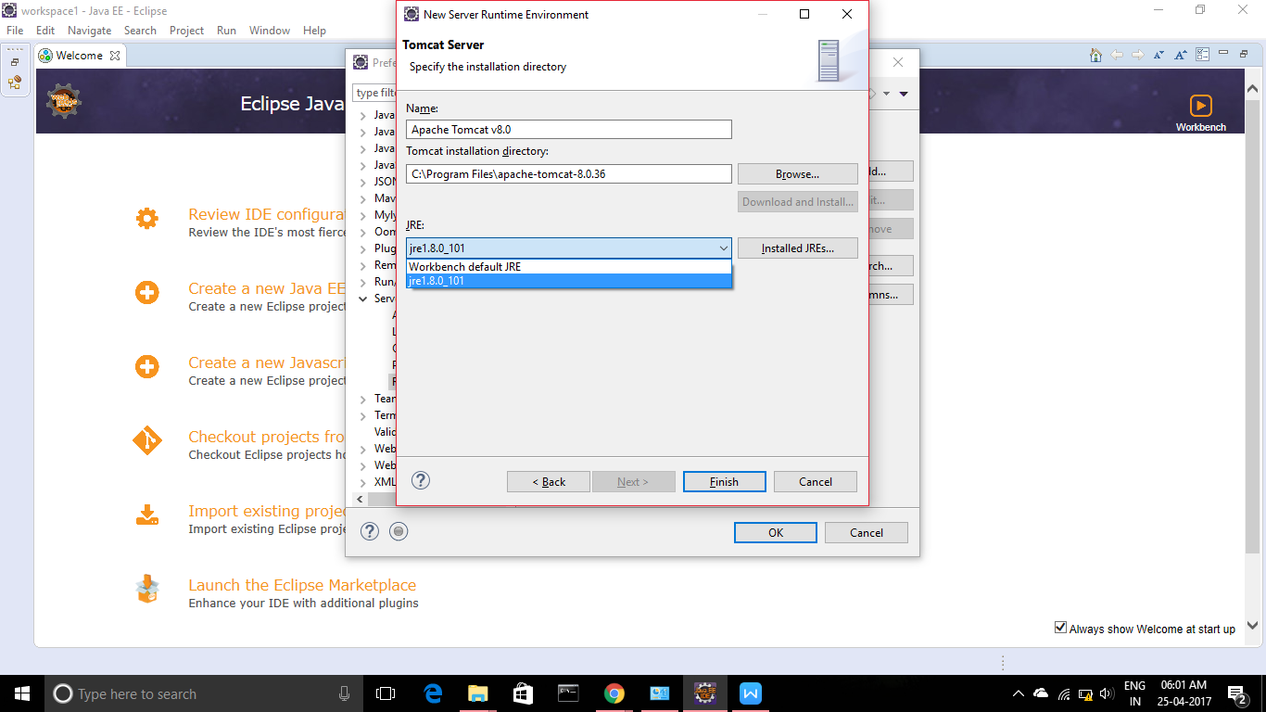

1. Click on OK to add the server

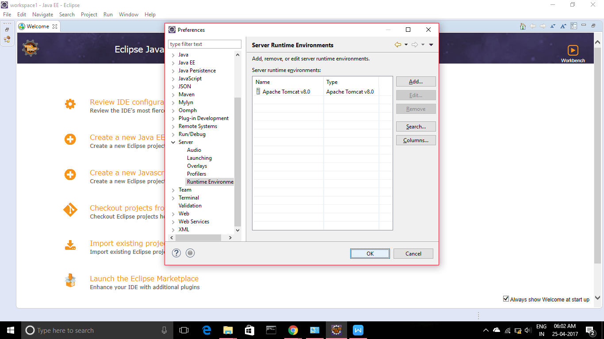

**Installing Apache Tomcat on Linux**

The pre-requisites for installing Apache Tomcat server on Linux are

* Java SE Runtime Environment (JRE)
* Java Development Kit (JDK)

To install Tomcat on Linux use the command

$yum install tomcat

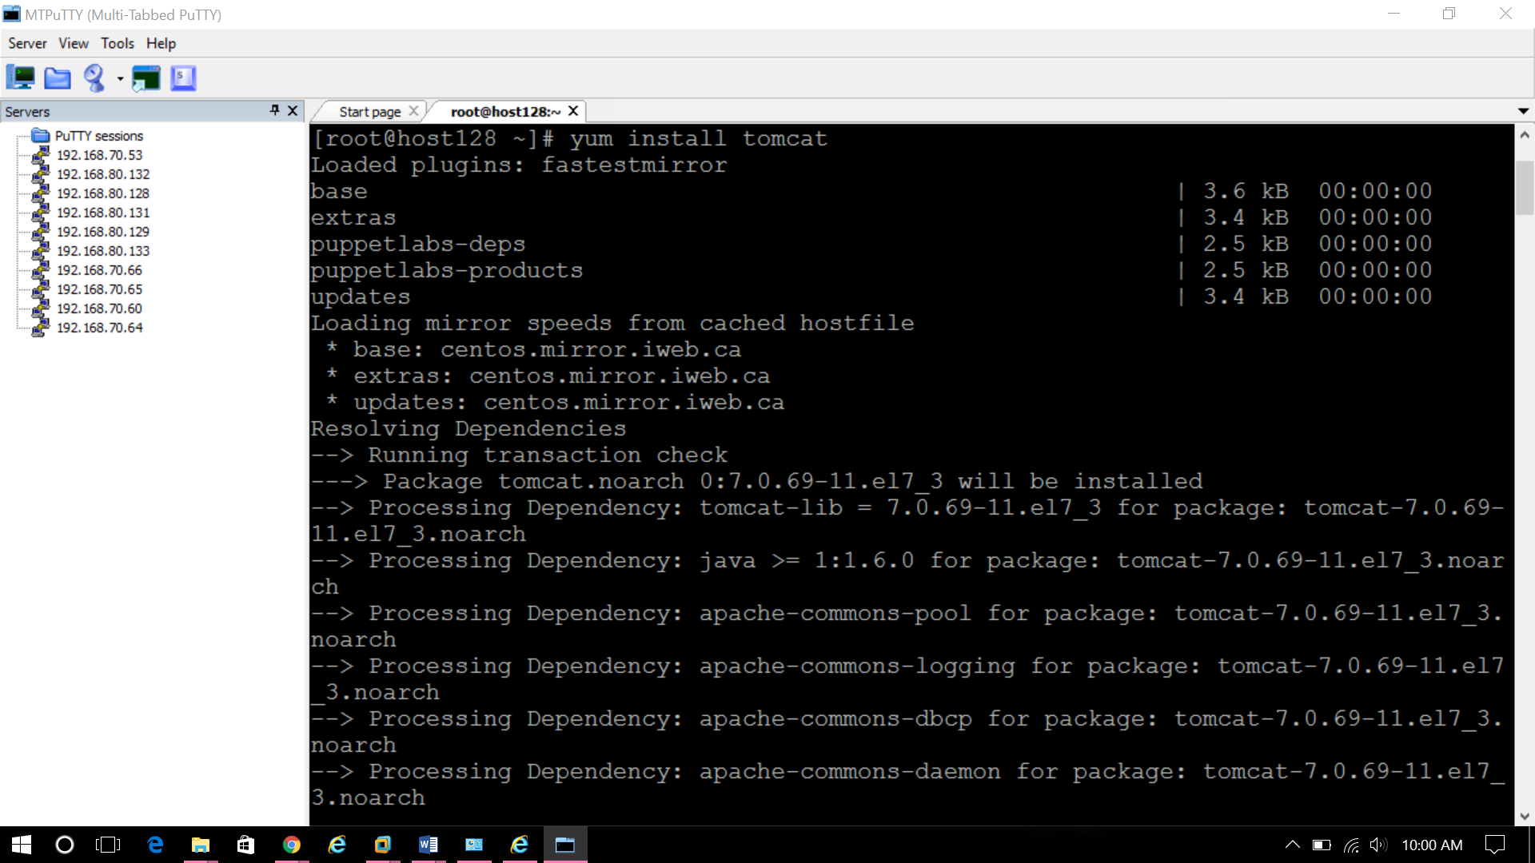

The service name for tomcat is “tomcat”. The command to start the service is

$service tomcat start

(or)

$systemctl start tomcat

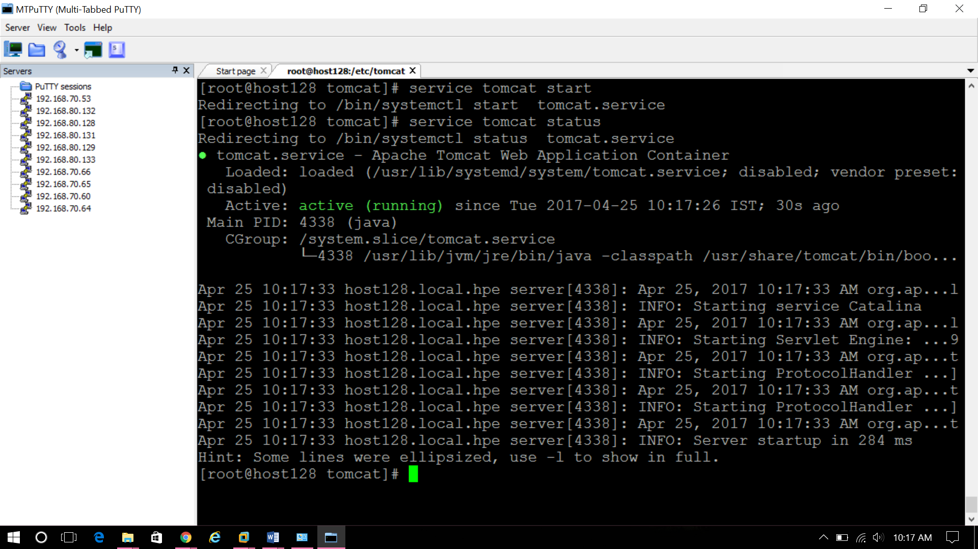

The home directory for Tomcat server is

/usr/sbin/tomcat

The configuration files will be stored in

/etc/tomcat/

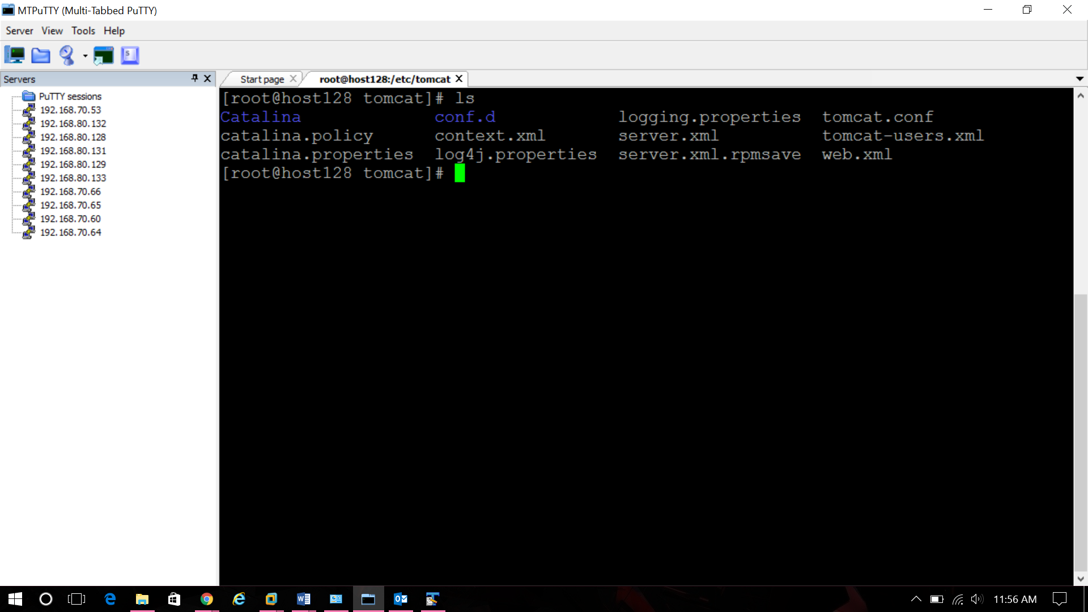

The port number of tomcat is by default, 8080. To change this, go to

$vim /etc/tomcat/server.xml

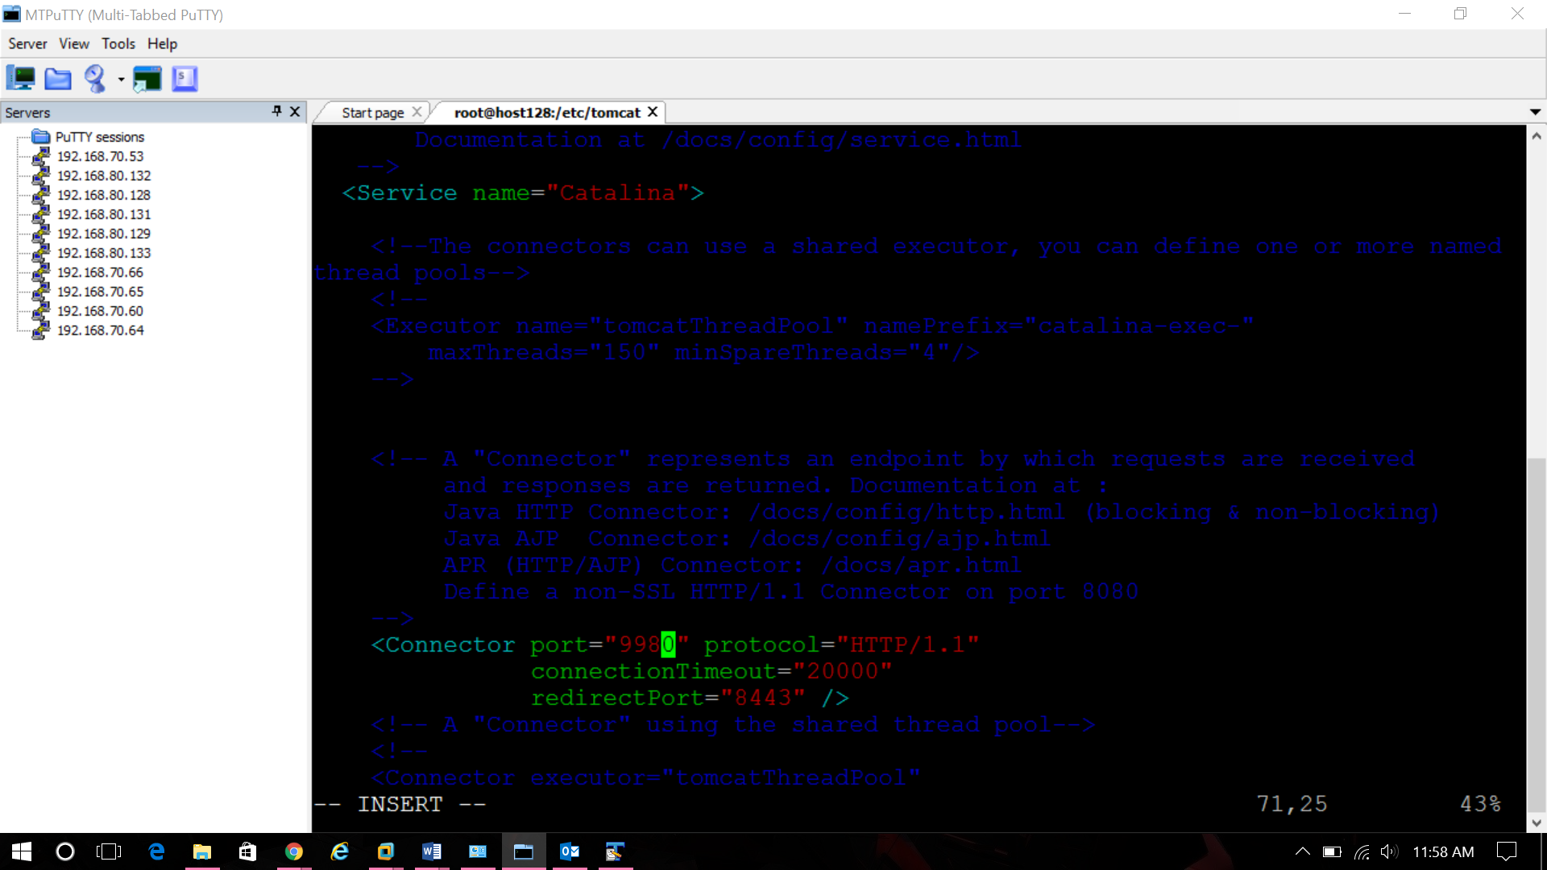

To access the server, open the browser give the URL as <http://192.168.80.128:8090> (The IP of the machine which is used to deploy tomcat should be given along with the port number). Here 8090 is the default port number.



**To add users to tomcat,**

1. Change the directory to tomcat directory

$cd /etc/tomcat

$vim tomcat-users.xml

1. Add the users in this file

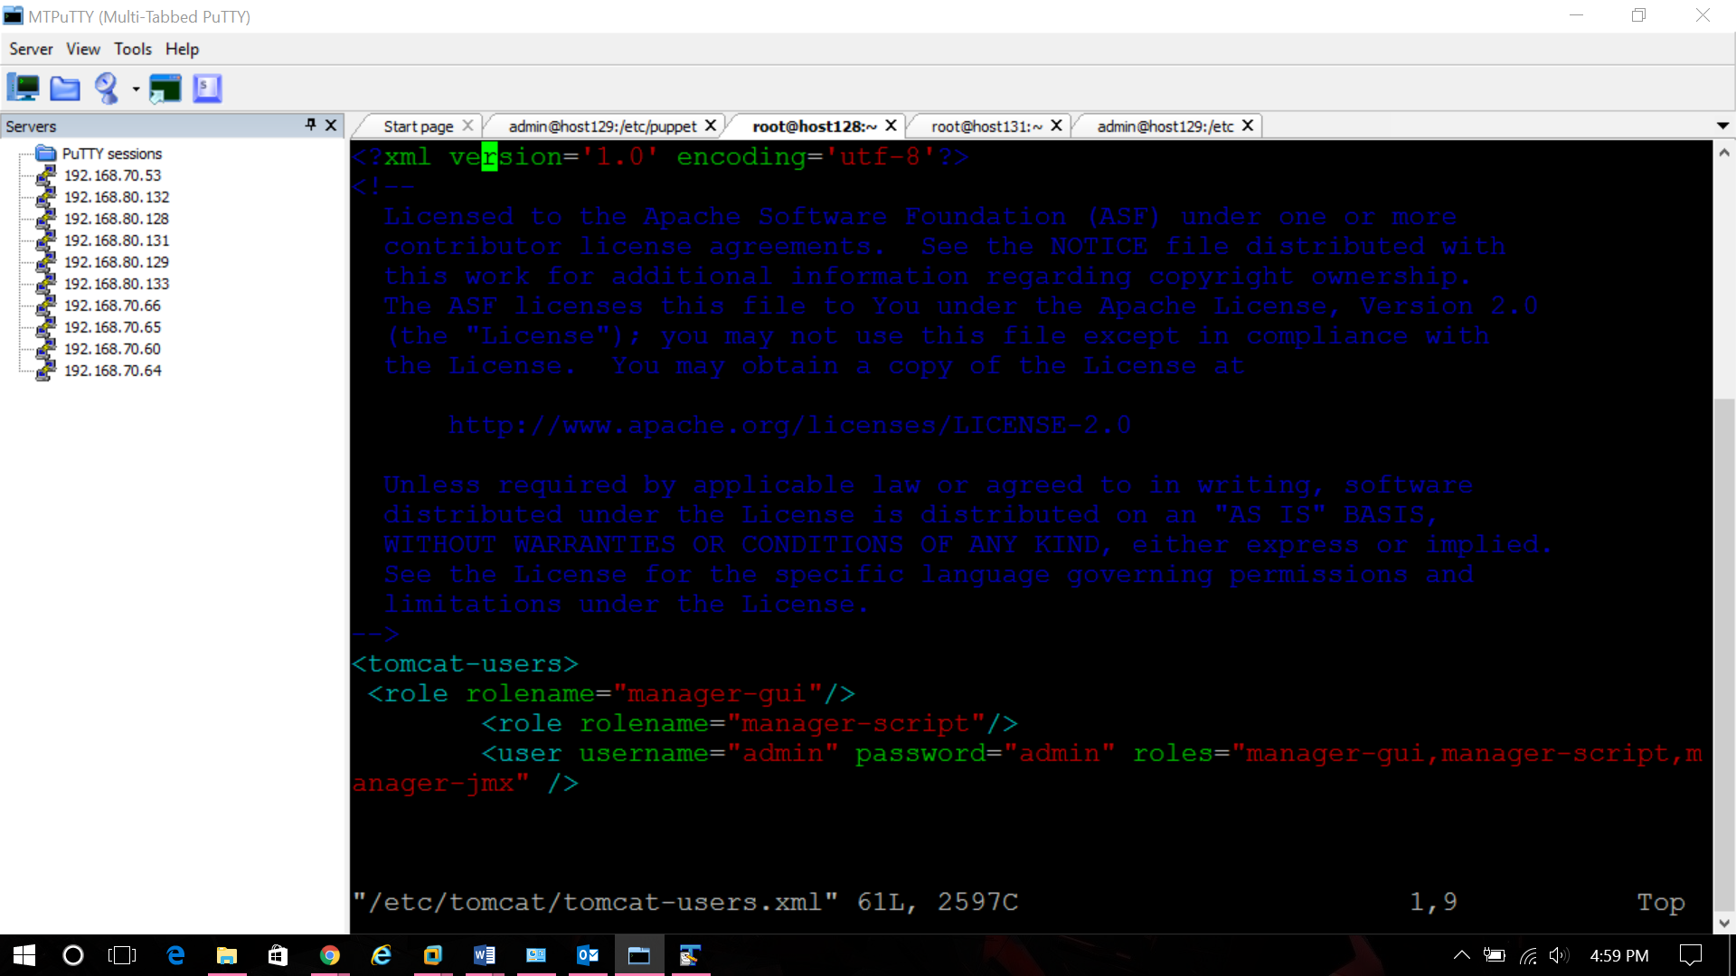

1. To login to tomcat, go to <http://192.168.80.128:8090>, click on Manage App. Use the username and password specified before to login.

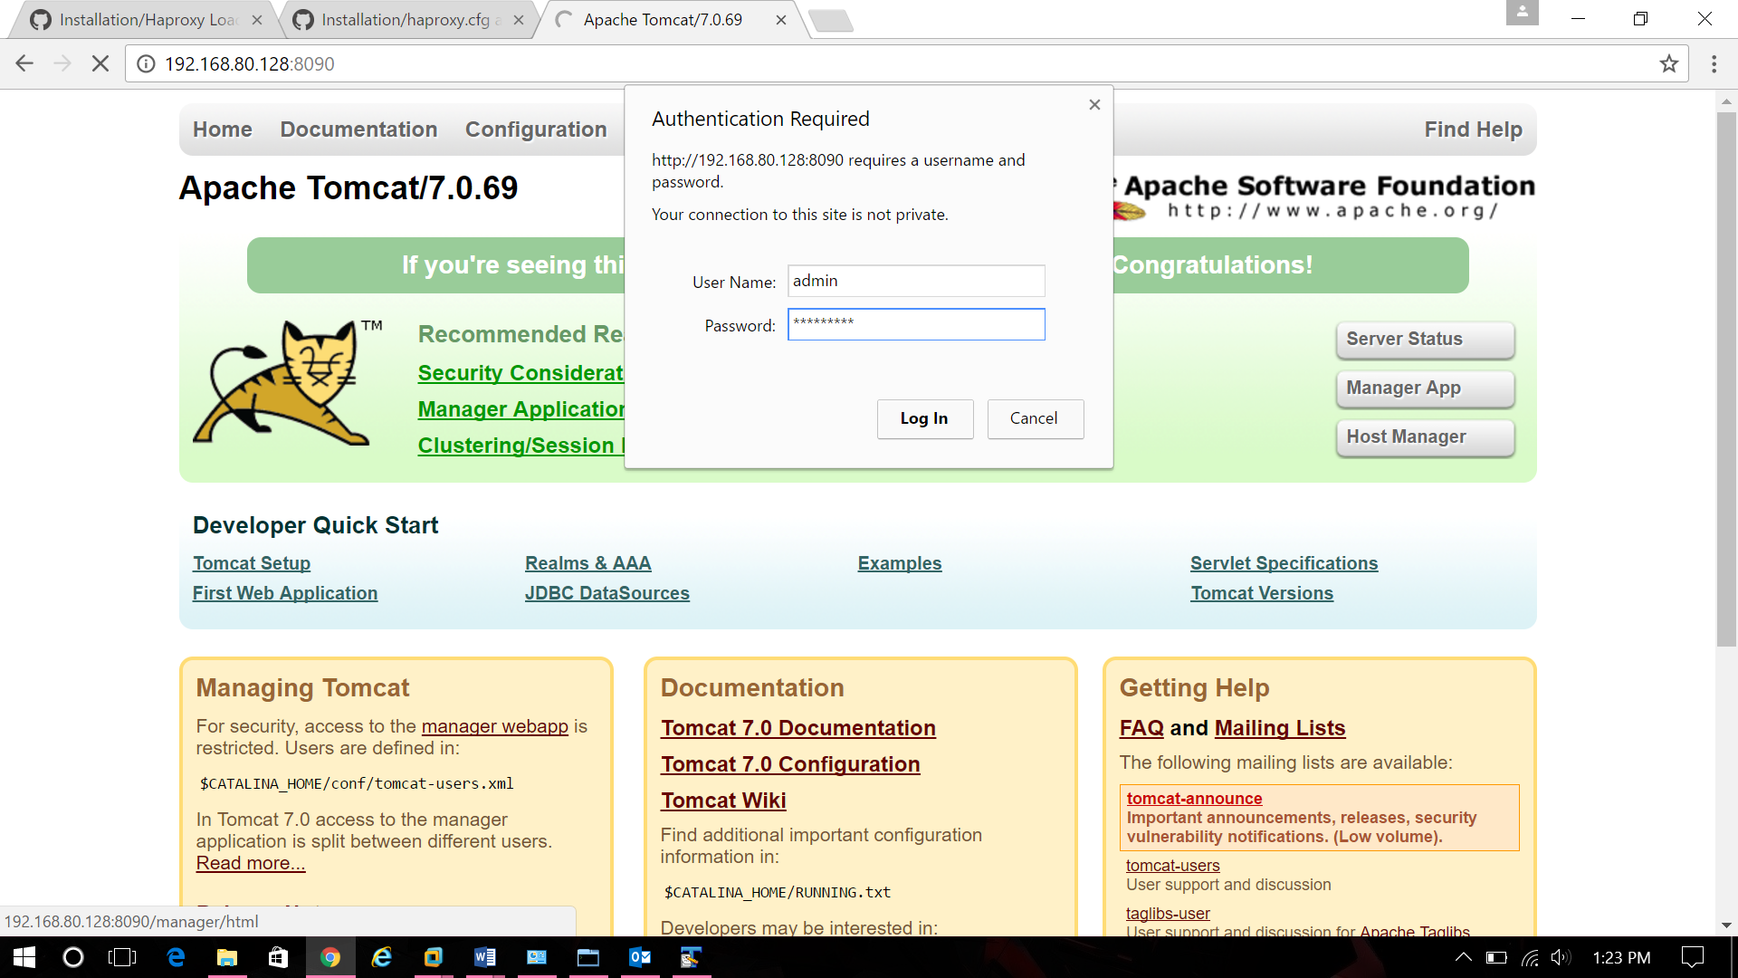

The tomcat manager looks like,

